Read a Book, Find a Friend

Newbery and Caldecott

Dear Students,
I have loved to read for as long as I can remember. As I grew up, I learned to enjoy many types of books. I have created this bibliography, a suggested list of titles, for you. Use it when you aren’t sure what to read or when you want to find something new. This list is divided into sections, including picture books and easy readers, fiction books, nonfiction books, magazines, and diversity books on physical disabilities. Read the descriptions to find a new book or magazine that you might like to check out.
You’ll find that when you read a book that interests you, you will enjoy it so much more. Books have a special way of connecting to our lives. Pick up a new book today, and you may find a friend within.
Hope you find a new friend soon,
Mrs. Harmon

Newbery and Caldecott Books

Newbery and Caldecott books are books that have won national awards. The American Library Association awards the Newbery to the book with the best story, usually a chapter book. They award the Caldecott to the best illustrated book, usually a picture book.

Title: Julie of the Wolves
Author: Jean Craighead George
Call Number: FIC GEO
Award: Newbery
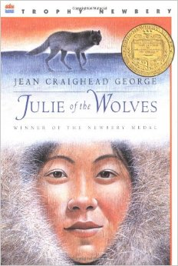
Why you should read this book:
At 13, an orphan, and unhappily married, Miyax runs away from her husband's parents' home, hoping to reach San Francisco and her pen pal. But she becomes lost in the vast Alaskan tundra, with no food, no shelter, and no idea which is the way to safety. When a pack of wolves begins to accept her into their community, Miyax must learn to think like a wolf. If she trusts her Eskimo instincts, will she stand a chance of surviving?
George, Jean Craighead. Julie of the Wolves. New York: HaperCollins, 1972.
Title: Amos Fortune, Free Man
Author: Elizabeth Yates
Call Number: FIC YAT
Award: Newbery
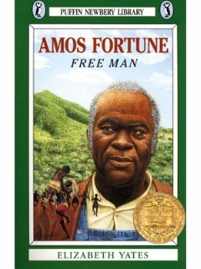
Why you should read this book:
When Amos Fortune was only fifteen years old, he was captured by slave traders and brought to Massachusetts, where he was sold at auction. Although his freedom had been taken, Amos never lost his dinity and courage. For 45 years, Amos worked as a slave and dreamed of freedom. And, at age 60, he finally began to see those dreams come true.
Yates, Elizabeth. Amos Fortune, Free Man. New York: Dutton, 1950.

Title: Bridge to Terabithia
Author: Katherine Paterson
Call Number: FIC PAT
Award: Newbery
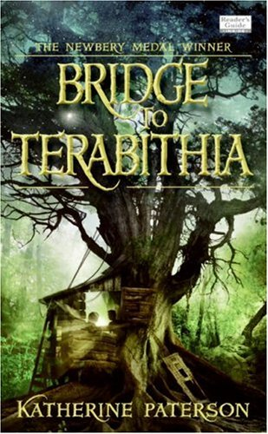
Why you should read this book:
Jess Aarons' greatest ambition is to be the fastest runner in his grade. He's been practicing all summer and can't wait to see his classmates' faces when he beats them all. But on the first day of school, a new girl boldly crosses over to the boys' side and outruns everyone. That's not a very promising beginning for a friendship, but Jess and Leslie Burke become inseparable. Together they create Terabithia, a magical kingdom in the woods where the two of them reign as king and queen, and their imaginations set the only limits.
Paterson, Katherine. Bridge to Terabithia. New York: HarperCollins, 1977.
Title: Caddie Woodlawn
Author: Carol Ryrie Brink
Call Number: FIC BRI
Award: Newbery
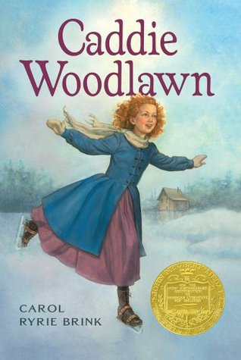
Why you should read this book:
Caddie Woodlawn is an adventurer. She'd rather hunt than sew and plow than bake, and tries to beat her brother's dares every chance she gets. Caddie is friends with Indians, who scare most of the neighbors who, like her mother and sisters, don't understand her at all.
Brink, Carol Ryrie. Caddie Woodlawn. New York: McMillan, 1935.

Title: Call It Courage
Author: Armstrong Sperry
Call Number: FIC SPE
Award: Newbery
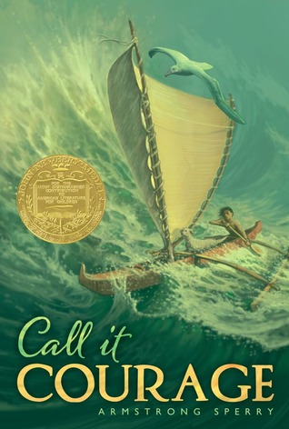
Why you should read this book:
Maftu was afraid of the sea. It had taken his mother when he was a baby, and the sea gods sought vengeance at having been cheated of Mafatu. Though he was the son of the Great Chief of Hikueru, a race of Polynesians who worshipped courage, and he was named Stout Heart, he feared and avoided tha sea, until everyone branded him a coward. When he could no longer bear their taunts and jibes, he determined to conquer that fear or be conquered-- so he went off in his canoe, alone except for his little dog and pet albatross.
Sperry, Armstrong. Call It Courage. Santa Barbara, CA: Cornerstone Books, 1940.

Title: Carry on Mr. Bowditch
Author: John Lee Latham
Call Number: FIC LAT
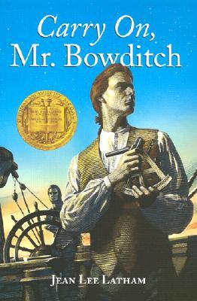
Why you should read this book:
Nathaniel Bowditch grew up in a sailor’s world—Salem in the early days, when tall-masted ships from foreign ports crowded the wharves. But Nat didn’t promise to have the makings of a sailor; he was too physically small. Nat may have been slight of build, but no one guessed that he had the persistence and determination to master sea navigation in the days when men sailed only by “log, lead, and lookout.”
Latham, John Lee. Carry on Mr. Bowditch. Boston: Houghton Mifflin,1995.

Title: Crispin: The Cross of Lead
Author: Avi
Call Number: FIC AVI

Why you should read this book:
"Asta's Son" is all he's ever been called. The lack of a name is appropriate, because he and his mother are but poor peasants in 14th century medieval England. But this thirteen-year-old boy who thought he had little to lose soon finds himself with even less - no home, no family, or possessions. Accused of a crime he did not commit, he may be killed on sight, by anyone. If he wishes to remain alive, he must flee his tiny village. All the boy takes with him is a newly revealed name - Crispin - and his mother's cross of lead.
Avi. Crispin: The Cross of Lead. New York: Hyperion Books for Children, 2002.

Title: Criss Cross
Author: Perkins, Lynne Rae
Call Number: FIC PER
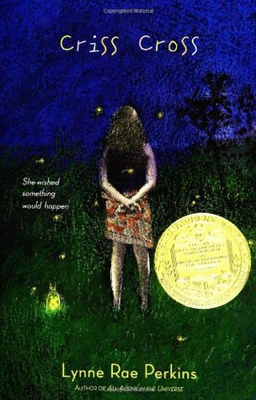
Why you should read this book:
She wished something would happen. Something good. To her. Looking at the bright, fuzzy picture in the magazine, she thought, something like that. Checking her wish for loopholes, she found one. Hoping it wasn't too late, she thought the word soon.
Perkins, Lynne Rae. Criss Cross. New York: Greenwilow Books, 2005.

Title: Dicey’s Song
Author: Cynthia Voigt
Call Number: FIC VOI
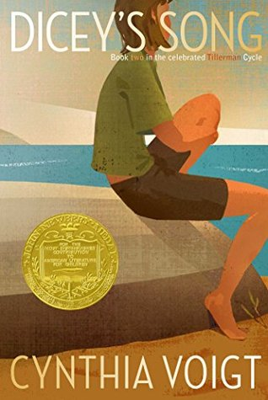
Why you should read this book:
When Momma abandoned Dicey Tillerman and her three siblings in a mall parking lot and was later traced to an asylum where she lay unrecognizing, unknowing, she left her four children no choice but to get on by themselves. They set off alone on foot over hundreds of miles until they finally found someone to take them in. Gram’s rundown farm isn’t perfect, but they can stay together as a family—which is all Dicey really wanted. But after watching over the others for so long, it’s hard for Dicey to know what to do now. Her own identity has been so wrapped up in being the caretaker, navigator, penny counter, and decision maker that she’s not sure how to let go of some responsibilities while still keeping a sense of herself. But when the past comes back with devastating force, Dicey sees just how necessary—and painful—letting go can be.
Voigt, Cynthia. Dicey’s Song. New York: Atheneum Press, 1983.

Title: From the mixed-up files of Mrs. Basil E. Frankweiler
Author: E. L. Konigsburg
Call Number: FIC KON
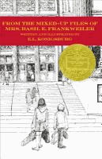
Why you should read this book:
When suburban Claudia Kincaid decides to run away, she knows she doesn’t just want to run from somewhere, she wants to run to somewhere — to a place that is comfortable, beautiful, and, preferably, elegant. She chooses the Metropolitan Museum of Art in New York City. Knowing her younger brother Jamie has money and thus can help her with a serious cash-flow problem, she invites him along. Once settled into the museum, her quest leads her to Mrs. Basil E. Frankweiler, the remarkable old woman who sold the statue, and to some equally remarkable discoveries about herself.
Konigsburg, E.L. From the Mixed Up Files of Mrs. Basil E. Frankweiler. New York: Atheneum Books for Young Readers, 1967.

Title: The Giver
Author: Lois Lowry
Call Number: FIC LOW
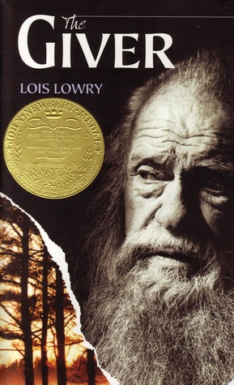
Why you should read this book:
Jonas's world is perfect. Everything is under control. There is no war or fear or pain. There are no choices. Every person is assigned a role in the Community. When Jonas turns twelve, he is singled out to receive special training from The Giver. The Giver alone holds the memories of the true pain and pleasure of life. Now, it is time for Jonas to receive the truth. There is no turning back.
Lowry, Lois. The Giver. Boston: Houghton Mifflin, 1993.

Title: The Higher Power of Lucky
Author: Susan Patron
Call Number: FIC PAT
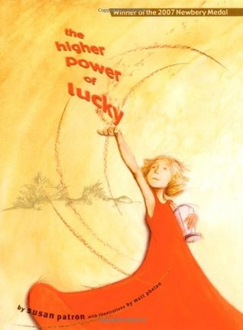
Why you should read this book:
Believing that her French guardian is about to abandon her to an orphanage in the city, ten-year-old Lucky runs away from her small town with her beloved dog by her side in order to trek across the Mojave Desert. It's all Brigitte's fault -- for wanting to go back to France. Guardians are supposed to stay put and look after girls in their care! She'll have to give up eavesdropping on twelve-step anonymous programs where the interesting talk is all about Higher Powers. Lucky needs her own -- and quick. But she hadn't planned on a dust storm. Or needing to lug the world's heaviest survival-kit backpack into the desert.
Patron, Susan. The Higher Power of Lucky. New York: Scholastic, Inc., 2006.
Title: Holes
Author: Louis Sachar
Call Number: FIC SAC
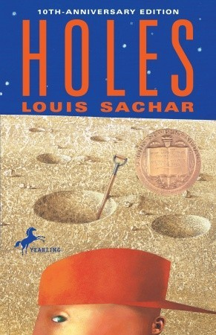
Why you should read this book:
Stanley Yelnats is under a curse. A curse that began with his no-good-dirty-rotten-pig-stealing-great-great-grandfather and has since followed generations of Yelnatses. Now Stanley has been unjustly sent to a boys’ detention center, Camp Green Lake, where the boys build character by spending all day, every day digging holes exactly five feet wide and five feet deep. There is no lake at Camp Green Lake. But there are an awful lot of holes. It doesn’t take long for Stanley to realize there’s more than character improvement going on at Camp Green Lake. The boys are digging holes because the warden is looking for something. But what could be buried under a dried-up lake? Stanley tries to dig up the truth in this inventive and darkly humorous tale of crime and punishment—and redemption.
Sachar, Louis. Holes. New York: Farrar, Straus, and Giroux, 1998.
Title: Invincible Louisa: the story of the author of Little Women
Author: Cornelia Meigs
Call Number: FIC MEI
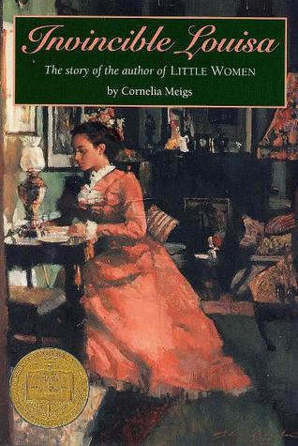
Why you should read this book:
Biography tracing the fascinating life of Louisa May Alcott from her happy childhood in Pennsylvania and Boston to her success as a writer of such classics as Little women.
Meigs, Cornelia. Artemis Fowl. Boston: Little Brown, 1968.

Title: Island of the Blue Dolphins
Author: Scott O’Dell
Call Number: FIC ODE
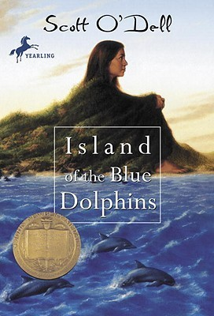
Why you should read this book:
In the Pacific there is an island that looks like a big fish sunning itself in the sea. Around it, blue dolphins swim, otters play, and sea elephants and sea birds abound. once, Indians also lived on the island. And when they left and sailed to the east, one young girl was left behind. — This is the story of Karana, the Indian girl who lived alone for years on the Island of the Blue Dolphins. Year after year, she watched one season pass into another and waited for a ship to take her away. But while she waited, she kept herself alive by building shelter, making weapons, finding food, and fighting her enemies, the wild dogs. It is not only an unusual adventure of survival, but also a tale of natural beauty and personal discovery.
O’Dell, Scott. Island of the Blue Dolphins. Boston: Houghton Mifflin, 1960.

Title: Kira-Kira
Author: Cynthia Kadohato
Call Number: E KAD
Why you should read this book:
When Katie and her family move from a Japanese community in Iowa to the Deep South of Georgia, it's Lynn who explains to her why people stop on the street to stare. And it's Lynn who, with her special way of viewing the world, teaches Katie to look beyond tomorrow. But when Lynn becomes desperately ill, and the whole family begins to fall apart, it is up to Katie to find a way to remind them all that there is always something glittering -- kira-kira -- in the future.
Kadohato, Cynthia. Kira-Kira. New York: Atheneum Books for Young Readers, 2004.

Title: Lincoln: A Photobiography
Author: Russell Freeman
Call Number: 921 LIN
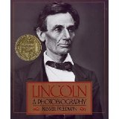
Why you should read this book:
Photographs and text trace the life of the Civil War President.
Cleary, Beverly. Ramona’s World. New York: Harper Collins Publishers, 2006.

Title: Missing May
Author: Cynthia Rylant
Call Number: FIC RYL
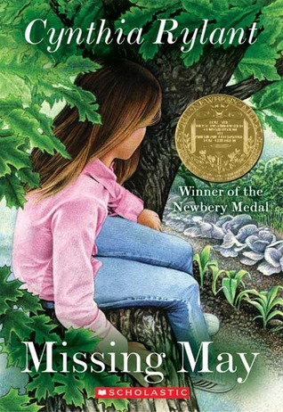
Why you should read this book:
When May dies suddenly while gardening, Summer assumes she'll never see her beloved aunt again. But then Summer's Uncle Ob claims that May is on her way back--she has sent a sign from the spirit world. Summer isn't sure she believes in the spirit world, but her quirky classmate Cletus Underwood--who befriends Ob during his time of mourning--does. So at Cletus' suggestion, Ob and Summer (with Cletus in tow) set off in search of Miriam B. Young, Small Medium at Large, whom they hope will explain May's departure and confirm her possible return.
Rylant, Cynthia. Missing May. New York: Bantam Doubleday Dell Books for Young Readers, 1992.

Title: Mrs. Frisby and the Rats of NIMH
Author: Robert C. O’Brien
Call Number: FIC OBR
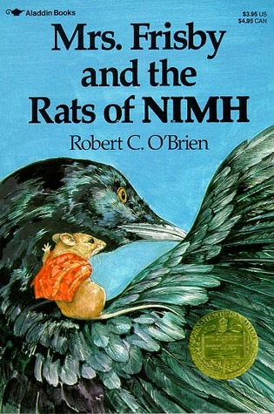
Why you should read this book:
Mrs. Frisby, a widowed mouse with four small children, must move her family to their summer quarters immediately, or face almost certain death. But her youngest son, Timothy, lies ill with pneumonia and must not be moved. Fortunately, she encounters the rats of NIMH, an extraordinary breed of highly intelligent creatures, who come up with a brilliant solution to her dilemma.
O’Brien, Robert C.. Mrs. Frisby and the Rats of NIMH. New York: Atheneum Books for Young Readers, 1971.

Title: Rifles for Watie
Author: Harold Keith
Call Number: FIC KEI
Why you should read this book:
Jeff Bussey walked briskly up the rutted wagon road toward Fort Leavenworth on his way to join the Union volunteers. It was 1861 in Linn County, Kansas, and Jeff was elated at the prospect of fighting for the North at last. In the Indian country south of Kansas there was dread in the air; and the name, Stand Watie, was on every tongue. A hero to the rebel, a devil to the Union man, Stand Watie led the Cherokee Indian Nation fearlessly and successfully on savage raids behind the Union lines. Jeff came to know the Watie men only too well.
Keith, Harold. Rifles for Watie. New York: HarperCollins, 1957.

Title: When You Reach Me
Author: Rebecca Stead
Call Number: FIC STE
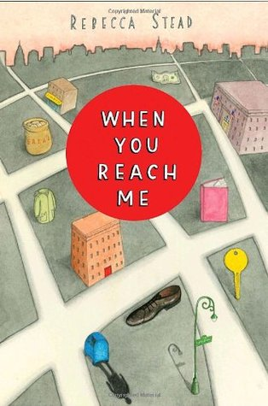
Why you should read this book:
By sixth grade, Miranda and her best friend, Sal, know how to navigate their New York City neighborhood. But things start to unravel. Sal gets punched by a new kid for what seems like no reason, and he shuts Miranda out of his life. The apartment key that Miranda’s mom keeps hidden for emergencies is stolen. And then Miranda finds a mysterious note scrawled on a tiny slip of paper:
I am coming to save your friend’s life, and my own.
I must ask two favors. First, you must write me a letter.
The notes keep coming, and Miranda slowly realizes that whoever is leaving them knows all about her, including things that have not even happened yet. Each message brings her closer to believing that only she can prevent a tragic death. Until the final note makes her think she’s too late.
Stead, Rebecca. When You Reach Me. New York: Wendy Lamb Books, 2009.
Title: The Whipping Boy
Author: Sid Fleischman
Call Number: FIC FLE
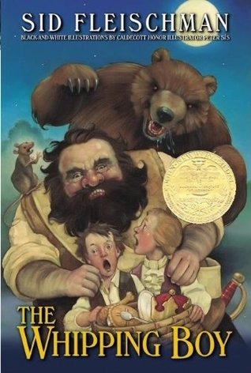
Why you should read this book:
A shout comes echoing up the stairway "Fetch the whipping boy!"A young orphan named Jemmy rouses from his sleep. "Ain't I already been whipped twice today? Gaw! What's the prince done now? It was forbidden to spank, thrash, or whack the heir to the throne. Jemmy had been plucked from the streets to serve as whipping boy to the arrogant and spiteful Prince Brat. Dreaming of running away, Jemmy finds himself trapped in Prince Brat's own dream, at once brash and perilous.
Fleischman, Sid. The Whipping Boy. New York: ABC Clio, 1989.

Title: A Wrinkle in Time
Author: Madeleine L’Engle
Call Number: FIC LEN
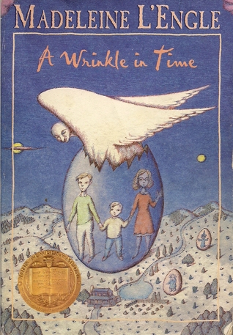
Why you should read this book:
It was a dark and stormy night; Meg Murry, her small brother Charles Wallace, and her mother had come down to the kitchen for a midnight snack when they were upset by the arrival of a most disturbing stranger. "Wild nights are my glory," the unearthly stranger told them. "I just got caught in a downdraft and blown off course. Let me be on my way. Speaking of way, by the way, there is such a thing as a tesseract". Meg's father had been experimenting with this fifth dimension of time travel when he mysteriously disappeared. Now the time has come for Meg, her friend Calvin, and Charles Wallace to rescue him. But can they outwit the forces of evil they will encounter on their heart-stopping journey through space?
L’Engle, Madeleine. A Wrinkle in Time. New York: Farrar, Straus, 1962.
Title: The View From Saturday
Author: E. L. Konigsburg
Call Number: FIC KON
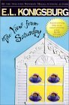
Why you should read this book:
Mrs Olinski, paralyzed ten years ago, returns to teaching Gr 6, and chooses four trivia team students, who become champions, in more than the state competition. Each narrates a section. Julian Singh, the strangest one on the school bus, invites Noah, red-haired Nadia, and silent Ethan, to Sillington House for tea 'always at four'.
Konisgburg, E.L. The View From Saturday. New York: Atheneum Books for Young Readers, 1996.

Title: Afternoon of the Elves
Author: Janet Taylor Lisle
Call Number: FIC LIS
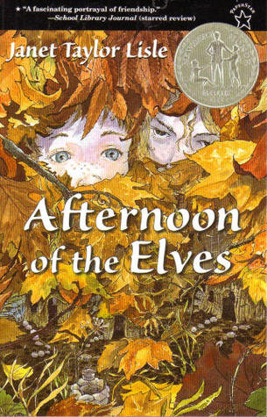
Why you should read this book:
Hillary doesn't believe all the mean things she hears about Sara-Kate. Sure, she wears weird clothes and she lives in a dumpy house, but if Sara-Kate's as bad as everyone says, how could she take such good care of the elf village in her backyard? She and Hillary spend hours fixing the tiny stick houses and the miniature Ferris wheel so the elves won't move away. But as Hillary is drawn further into Sara-Kate's world, she learns there are other mysteries besides the elves. Why doesn't anyone ever see Sara-Kate's mother? And why isn't anyone allowed in her house?
Lisle, Janet Taylor. Afternoon of the Elves. New York: Orchard Books, 1989.

Title: Bud, Not Buddy
Author: Christopher Paul Curtis
Call Number: FIC CUR
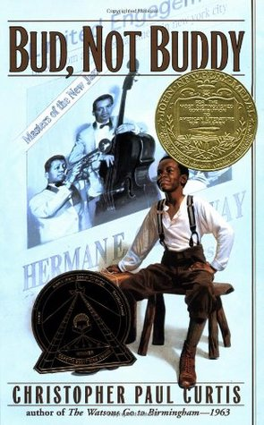
Why you should read this book:
It's 1936, in Flint, Michigan. Times may be hard, and ten-year-old Bud may be a motherless boy on the run, but Bud's got a few things going for him. He has his own suitcase filled with his own important, secret things. He's the author of Bud Caldwell's Rules and Things for Having a Funner Life and Making a Better Liar Out of Yourself. His momma never told him who his father was, but she left a clue: flyers of Herman E. Calloway and his famous band, the Dusky Devastators of the Depression! Bud's got an idea that those flyers will lead him to his father. Once he decides to hit the road and find this mystery man, nothing can stop him--not hunger, not fear, not vampires, not even Herman E. Calloway himself.
Curtis, Christopher Paul. Bud, Not Buddy. New York: Delacorte Press, 1999.
Title: The Graveyard Book
Author: Neil Gaiman
Call Number: FIC GAI
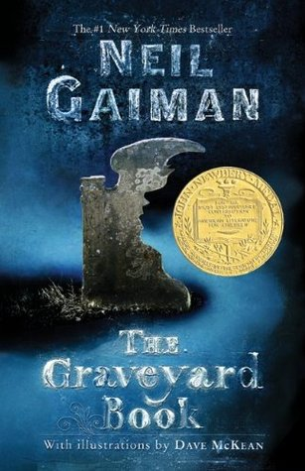
Why you should read this book:
After the grisly murder of his entire family, a toddler wanders into a graveyard where the ghosts and other supernatural residents agree to raise him as one of their own. Nobody Owens, known to his friends as Bod, is a normal boy. He would be completely normal if he didn't live in a sprawling graveyard, being raised and educated by ghosts, with a solitary guardian who belongs to neither the world of the living nor of the dead. There are dangers and adventures in the graveyard for a boy. But if Bod leaves the graveyard, then he will come under attack from the man Jack—who has already killed Bod's family.
Gaiman, Neil. The Graveyard Book. New York: HarperCollins, 2008.

Title: Flora & Ulysses
Author: Kate DiCamillo
Call Number: FIC DIC
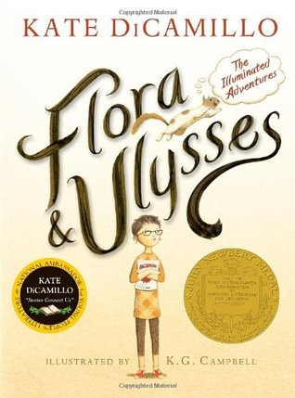
Why you sh
It begins, as the best superhero stories do, with a tragic accident that has unexpected consequences. The squirrel never saw the vacuum cleaner coming, but self-described cynic Flora Belle Buckman, who has read every issue of the comic book Terrible Things Can Happen to You!, is the just the right person to step in and save him. What neither can predict is that Ulysses (the squirrel) has been born anew, with powers of strength, flight, and misspelled poetry—and that Flora will be changed too, as she discovers the possibility of hope and the promise of a capacious heart.
DiCamillo, Kate. Flora & Ulysses. Somerville, MA: Candlewick Press, 2013.

Title: Moon Over Manifest
Author: Clare Vanderpool
Call Number: FIC VAN
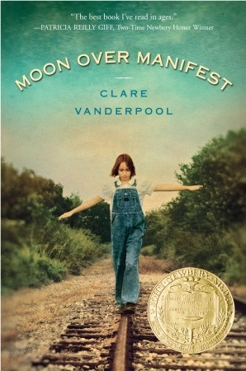
Why you should read this book:
Abilene Tucker feels abandoned. Her father has put her on a train, sending her off to live with an old friend for the summer while he works a railroad job. Armed only with a few possessions and her list of universals, Abilene jumps off the train in Manifest, Kansas, aiming to learn about the boy her father once was. Having heard stories about Manifest, Abilene is disappointed to find that it’s just a dried-up, worn-out old town. But her disappointment quickly turns to excitement when she discovers a hidden cigar box full of mementos, including some old letters that mention a spy known as the Rattler. These mysterious letters send Abilene and her new friends, Lettie and Ruthanne, on an honest-to-goodness spy hunt, even though they are warned to “Leave Well Enough Alone.”
Vanderpool, Clare. Moon Over Manifest. New York: Delacorte Press, 2010.
Title: Maniac Magee
Author: Jerry Spinelli
Call Number: FIC SPI
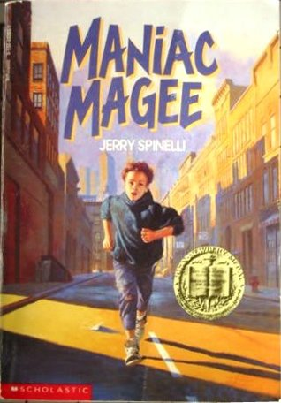
Why you should read this book:
Jeffrey Lionel "Maniac" Magee might have lived a normal life if a freak accident hadn't made him an orphan. After living with his unhappy and uptight aunt and uncle for eight years, he decides to run--and not just run away, but run. This is where the myth of Maniac Magee begins, as he changes the lives of a racially divided small town with his amazing and legendary feats.
Spinelli, Jerry. Maniac Magee. New York: Little Brown, 1990.

Title: Number the Stars
Author: Lois Lowry
Call Number: FIC LOW
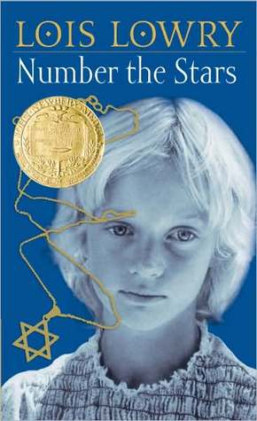
Why you should read this book:
Ten-year-old Annemarie Johansen and her best friend Ellen Rosen often think of life before the war. It's now 1943 and their life in Copenhagen is filled with school, food shortages, and the Nazi soldiers marching through town. When the Jews of Denmark are "relocated," Ellen moves in with the Johansens and pretends to be one of the family. Soon Annemarie is asked to go on a dangerous mission to save Ellen's life.
Lowry, Lois. Number the Stars. Boston: Houghton Mifflin, 1989.
Title: The One and Only Ivan
Author: Katherine Applegate
Call Number: FIC APP
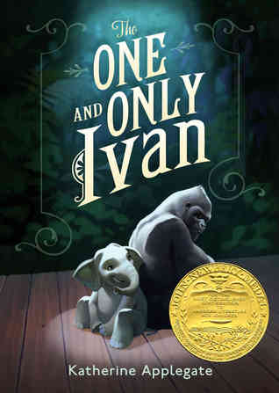
Why you should read this book:
Ivan is an easygoing gorilla. Living at the Exit 8 Big Top Mall and Video Arcade, he has grown accustomed to humans watching him through the glass walls of his domain. He rarely misses his life in the jungle. In fact, he hardly ever thinks about it at all. Instead, Ivan thinks about TV shows he’s seen and about his friends Stella, an elderly elephant, and Bob, a stray dog. But mostly Ivan thinks about art and how to capture the taste of a mango or the sound of leaves with color and a well-placed line. Then he meets Ruby, a baby elephant taken from her family, and she makes Ivan see their home—and his own art—through new eyes. When Ruby arrives, change comes with her, and it’s up to Ivan to make it a change for the better.
Applegate, Katherine. The One and Only Ivan. New York: Harper, 2012.
Title: Out of the Dust
Author: Karen Hesse
Call Number: FIC HES
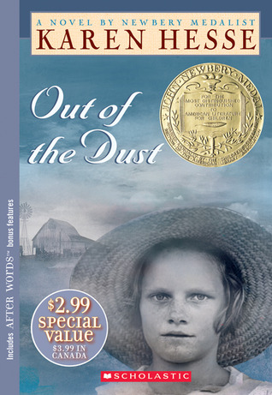
Why you should read this book:
When Billie Jo is just fourteen she must endure heart-wrenching ordeals that no child should have to face. The quiet strength she displays while dealing with unspeakable loss is as surprising as it is inspiring. Written in free verse, this award-winning story is set in the heart of the Great Depression. It chronicles Oklahoma's staggering dust storms, and the environmental--and emotional--turmoil they leave in their path. An unforgettable tribute to hope and inner strength.
Hesse, Karen. Out of the Dust. New York: Scholastic Press, 1997.
CALDECOTT

Title: Joseph Had a Little Overcoat
Author: Simms Taback
Call Number: E TAB
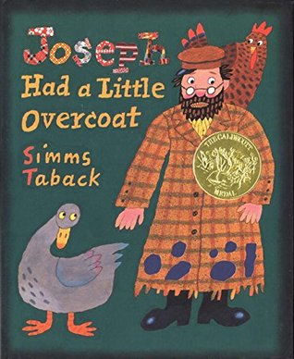
Why you should read this book:
Joseph had a little overcoat, but it was full of holes—just like this book! When Joseph's coat got too old and shabby, he made it into a jacket. But what did he make it into after that? And after that?As children turn the pages of this book, they can use the die-cut holes to guess what Joseph will be making next from his amazing overcoat, while they laugh at the bold, cheerful artwork and learn that you can always make something, even out of nothing.
Taback, Simms. Joseph Had a Little Overcoat. New York: Viking, 1977.
Title: The Big Snow
Author: Berta and Elmer Hader
Call Number: E HAD
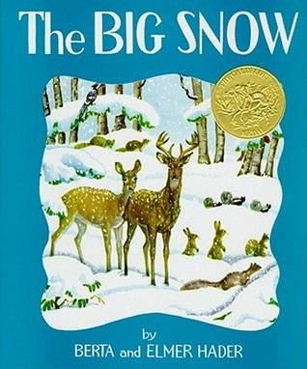
Why you should read this book:
When the geese begin to fly south, the leaves flutter down from the trees and the cold winds begin to blow from the north, the animals of the woods and meadows, big and small, prepare for the long, cold winter ahead when the countryside is hidden under a deep blanket of snow. They gather food and look for warm, snug places in the ground, trees, caves or thickets, where they can find protection against the icy winds. It might have been hard for the birds and animals of the hillside to survive when the Big Snow came if their good friends, who lived in the little stone house, had not remembered to put food out for them.
Hader, Berta, and Elmer Hader. The Big Snow. New York: MacMillon, 1948.
Title: Drummer Hoff
Author: Barbara Emberley
Call Number: E EMB
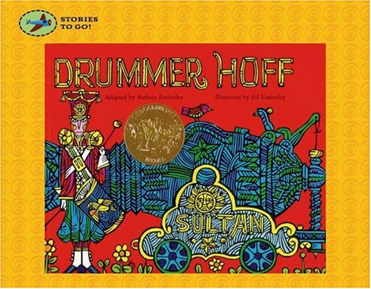
Why you should read this book:
"DRUMMER HOFF" is a lively folk verse all about the building of a cannon. Brightly dressed in full uniform, each soldier brings a part for the remarkable machine.
Emberley, Barbara. Drummer Hoff. New York: Simon & Schuster, 1987.
Title: Flotsam
Author: David Weisner
Call Number: E WEI
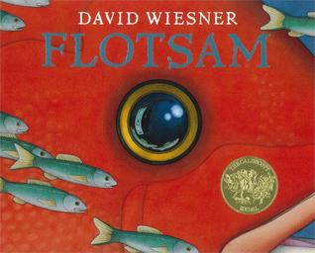
Why you should read this book:
A bright, science-minded boy goes to the beach equipped to collect and examine flotsam--anything floating that has been washed ashore. Bottles, lost toys, small objects of every description are among his usual finds. But there's no way he could have prepared for one particular discovery: a barnacle-encrusted underwater camera, with its own secrets to share . . . and to keep.
Weisner, David. Flotsam. New York: Clarion Books, 2006.
Title: Frog Went A-Courtin’
Author: John Langstaff
Call Number: 782.4 LAN
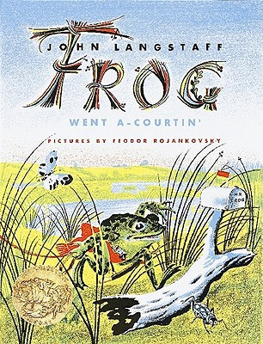
Why you should read this book:
“A favorite old nursery ballad now appears in resplendent new dress. . . . Illustrator Feodor Rojankovsky somehow manages to combine quaintness with sophistication and his doughty frog, the coy mouse . . . and others make charming company.”
Langstaff, John. Frog Went a-Courtin’. Orlando, FL: Harcourt, 1983 .
Title: Golem
Author: David Wisniewski
Call Number: E WIS
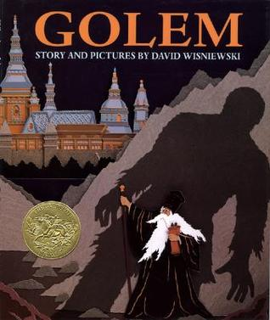
Why you should read this book:
A saintly rabbi miraculously brings to life a clay giant who helps him watch over the Jews of sixteenth-century Prague.
Wisniewski, David. Golem. New York: Clarion Books, 1996.
Title: Grandfather’s Journey
Author: Allen Say
Call Number: E SAY
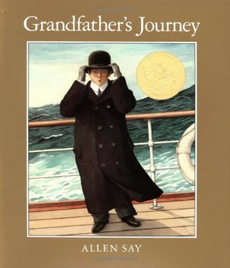
Why you should read this book:
A Japanese-American man recounts his grandfather's journey to America, which he later also undertakes, and the feelings of being torn by a love for two different countries.
Say Allen. Grandfather’s Journey. Boston: Houghton Mifflin, 1993.
Title: Hey, Al
Author: Arthur Yorinks
Call Number: E YOR
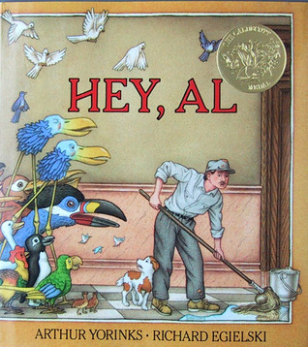
Why you should read this book:
A city janitor and his treasured canine companion are transported by a large colorful bird to an island in the sky, where their comfortable paradise existence threatens to turn them into birds as well.
Yorinks, Arthur. Hey, Al. New York: Farrar, Straus, and Giroux, 1986.
Title: The House in the Night
Author: Susan Marie Swanson
Call Number: E SWA
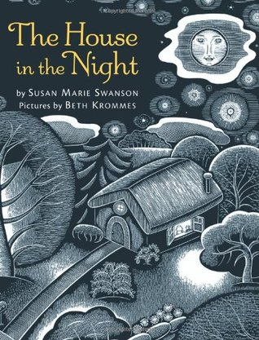
Why you should read this book:
Illustrations and easy-to-read text explore the light that makes a house in the night a home filled with light.
Swanson, Susan Marie. The House in the Night. Boston: Houghton Mifflin, 2008.
Title: Kitten’s First Full Moon
Author: Kevin Henkes
Call Number: E HEN
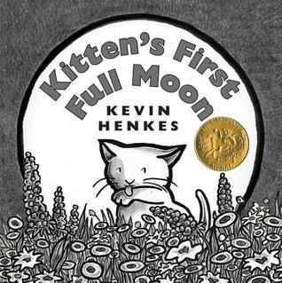
Why you should read this book:
When Kitten mistakes the full moon for a bowl of milk, she ends up tired, wet, and hungry trying to reach it.
Henkes, Kevin. Kitten’s First Full Moon. New York: Greenwillow Books, 2004.
Title: Madeline
Author: Ludwig Bemelmens
Call Number: E BEM
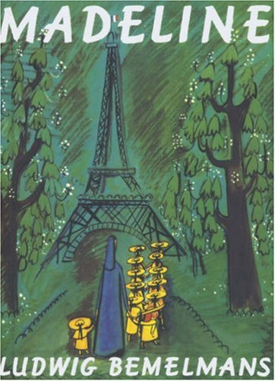
Why you should read this book:
Madeline, smallest and naughtiest of the twelve little charges of Miss Clavel, wakes up one night with an attack of appendicitis.
Bemelmens, Ludwig. Madeline. New York: Greenwillow Books, 2004.
Title: The Man Who Walked Between the Towers
Author: Mordicai Gerstein
Call Number: 791.3 GER
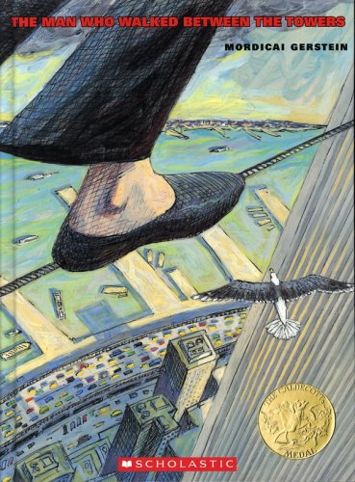
Why you should read this book:
A lyrical evocation of Philippe Petit's 1974 tightrope walk between the World Trade Center towers.
Gerstein, Mordicai. The Man Who Walked Between the Two Towers. Brookfield, Conn: Roaring Book Press, 2003.
Title: Many Moons
Author: James Thurber
Call Number: E THU
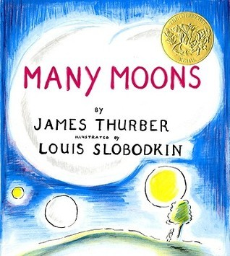
Why you should read this book:
Though many try, only the court jester is able to fulfill Princess Lenore's wish for the moon.
Thurber, James. Many Moons. San Diego, CA: Harcourt Brace, 1990.
Title: Mirette on the High Wire
Author: Emily Arnold McCully
Call Number: E MCC
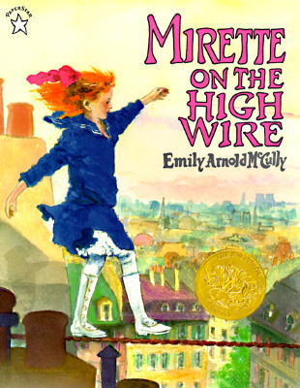
Why you should read this book:
Mirette learns tightrope walking from Monsieur Bellini, a guest in her mother's boarding house, not knowing that he is a celebrated tightrope artist who has withdrawn from performing because of fear.
McCully, Emily Arnold. Mirette on the High Wire. New York: G.P. Putnam’s Sons, 1992.

Title: My Friend Rabbit
Author: Eric Rohmann
Call Number: E ROH
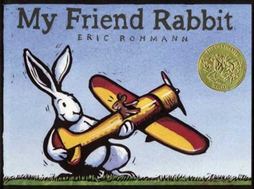
Why you should read this book:
Something always seems to go wrong when Rabbit is around, but Mouse lets him play with his toy plane anyway because he is his good friend.
Rohmann, Eric. My Friend Rabbit. New Milford, Conn: Roaring Brook Press, 2002.

Title: Noah’s Ark
Author: Peter Spier
Call Number: E SPI
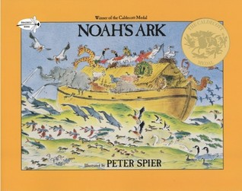
Why you should read this book:
Retells in pictures the Old Testament story of Noah, who built an ark to hold his family and the animals during the great flood.
Spier, Peter. Noah’s Ark. New York: Bantam Doubleday Dell Books for Young Readers, 1977.

Title: Officer Buckle and Gloria
Author: Peggy Rathmann
Call Number: E RAT
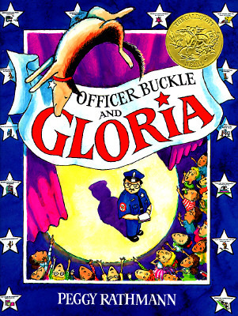
Why you should read this book:
The children at Napville Elementary School always ignore Officer Buckle's safety tips, until a police dog named Gloria accompanies him when he gives his safety speeches.
Rathmann, Peggy. Officer Buckle and Gloria. New York: Putnam’s, 1995.

Title: The Polar Express
Author: Chris Van Allsburg
Call Number: E VAN
Why you should read this book:
A magical train ride on Christmas Eve takes a boy to the North Pole to receive a special gift from Santa Claus.
Van Allsburg, Chris. The Polar Express. Boston: Houghton Mifflin, 1985.

Title: Rapunzel
Author: Paul Zelinsky
Call Number: 398.2 ZEL
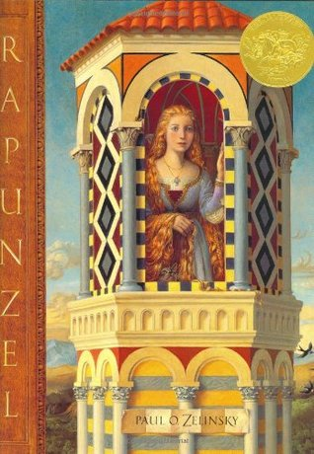
Why you should read this book:
A retelling of a folktale in which a beautiful girl with long golden hair is kept imprisoned in a lonely tower by a sorceress. Includes a note that traces the Italian, French, and German origins of the story, and discusses the author's decision to mimic the style of Italian Renaissance art in his illustrations.
Zelinsky, Paul. Rapunzel. New York: Dutton Children’s Books, 1997.

Title: Shadow
Author: Marcia Brown
Call Number: 841 BRO
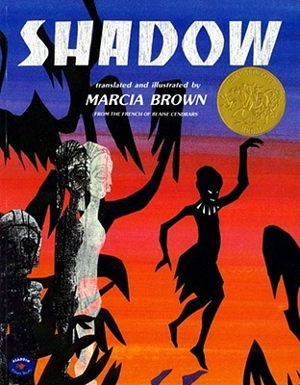
Why you should read this book:
Free verse evocation of the eerie, shifting images of Shadow which represents the beliefs and ghosts of the past and is brought to life wherever there is light, fire, and a storyteller.
Brown, Marcia. Shadow. New York: Aladdin Paperbacks, 1982.
Title: A Sick Day for Amos McGee
Author: Phillip Stead
Call Number: E STE
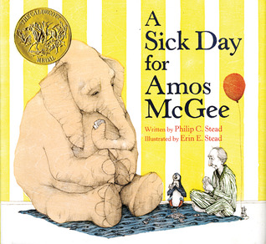
Why you should read this book:
Zookeeper Amos McGee, who is adored by all the animals, gets some unexpected guests while home sick one day.
Stead, Phillip. A Sick Day for Amos McGee. New York: Roaring Brook Press, 2010.
Title: Smoky Night
Author: Eve Bunting
Call Number: E BUN
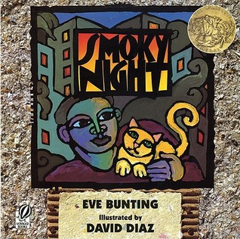
Why you should read this book:
When the Los Angeles riots break out in the streets of their neighborhood, a young boy and his mother learn the values of getting along with others no matter what their background or nationality.
Bunting, Eve. Smoky Night. San Diego, CA: Harcourt Brace, 1994.
Title: The Snowy Day
Author: Ezra Jack Keats
Call Number: E KEA
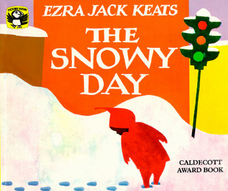
Why you should read this book:
The adventures of a little boy in the city on a very snowy day.
Keats, Ezra Jack. The Snowy Day. New York: Viking, 1996.
Title: So You Want to Be President
Author: Judith St. George
Call Number: 973 ST
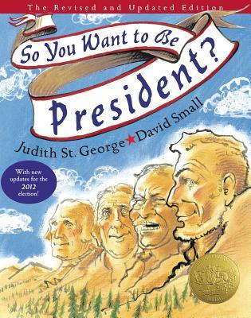
Why you should read this book:
Presents an assortment of facts about the qualifications and characteristics of U.S. presidents, from George Washington to Bill Clinton.
St. George, Judith. So You Want to Be President. New York: Philomel Books, 2000.
Title: Sy lvester and the Magic Pebble
Author: William Steig
Call Number: E STE
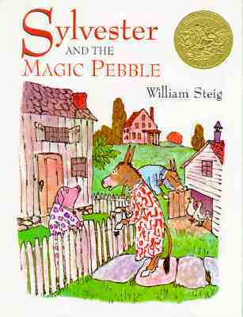
Why you should read this book:
In a moment of fright, Sylvester the donkey asks his magic pebble to turn into a rock but then can not hold the pebble to wish himself back to normal again.
Steig, William. Sylvester and the Magic Pebble. New York: Aladdin Paperbacks, 1969.
Title: This Is Not My Hat
Author: Jon Klassen
Call Number: E KLA
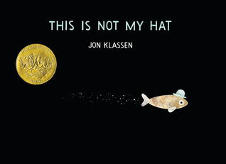
Why you should read this book:
A tiny fish wearing a blue hat hopes not to wake up the trouble that might be following close behind.
Klassen, Jon. This Is Not My Hat. Somerville, MA: Candlewick Press, 2012.
Title: The Three Pigs
Author: David Wiesner
Call Number: E WIE
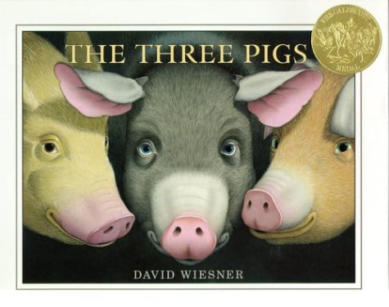
Why you should read this book:
The three pigs escape the wolf by going into another world where they meet the cat and the fiddle, the cow that jumped over the moon, and a dragon.
Wiesner, David. The Three Pigs. New York: Clarion Books, 2001.
Title: Tuesday
Author: David Wiesner
Call Number: E WIE
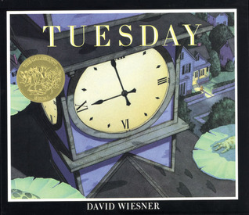
Why you should read this book:
Frogs rise on their lily pads, float through the air, and explore the nearby houses while their inhabitants sleep.
Wiesner, David. Tuesday. New York: Clarion Books, 1991.
Title: Where the Wild Things Are
Author: Maurice Sendak
Call Number: E SEN
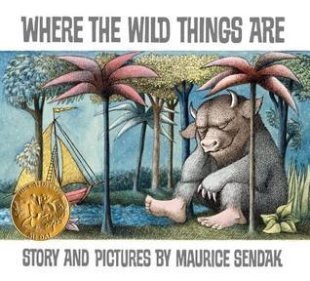
Why you should read this book:
A naughty little boy, sent to bed without his supper, sails to the land of the wild things where he becomes their king.
Sendak, Maurice. Where the Wild Things Are. New York: Harper & Row, 1963.
Title: Black and White
Author: David Macaulay
Call Number: E MAC
Why you should read this book:
Four brief "stories" about parents, trains, and cows, or is it really all one story?
Macaulay, David. Black and White. Boston: Houghton Mifflin, 1990.
Title: The Hello, Goodbye Window
Author: Norton Juster
Call Number: E JUS
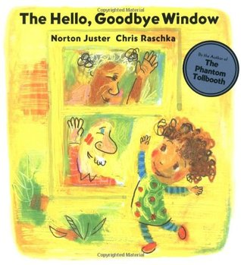
Why you should read this book:
Everything important in one little girl's life happens near, through or beyond her Nanna and Poppy's kitchen window.
Juster, Norton. The Hello, Goodbye Window. New York: Hyperion Books for Children, 2005.
Title: The Invention of Hugo Cabret
Author: Brian Selznik
Call Number: FIC SEL
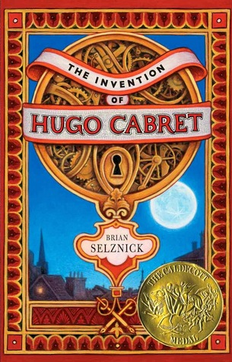
Why you should read this book:
When twelve-year-old Hugo, an orphan living and repairing clocks within the walls of a Paris train station in 1931, meets a mysterious toy seller and his goddaughter, his undercover life and his biggest secret are jeopardized.
Selznik, Brian. The Invention of Hugo Cabret. New York: Scholastic Press, 2007.
Title: The Lion and the Mouse
Author: Jerry Pinkney
Call Number: E PIN
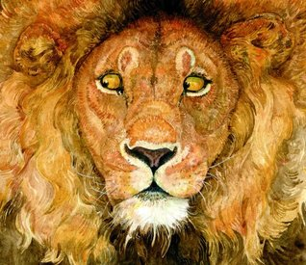
Why you should read this book:
In this wordless retelling of an Aesop fable, an adventuresome mouse proves that even small creatures are capable of great deeds when he rescues the King of the Jungle.
Pinkney, Jerry. The Lion and the Mouse. New York: Morrow Junior Books, 2009.
Title: Locomotive
Author: Brian Floca
Call Number: 385 FLO
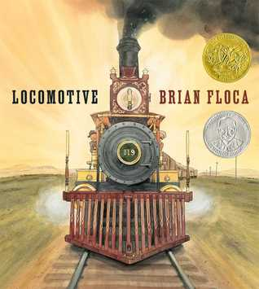
Why you should read this book:
Details what the first passengers experienced as they traveled West on the transcontinental railroad in the summer of 1869.
Floca, Brian. Locomotive. New York: Atheneum Books for Young Readers, 2013.
Title: Make Way For Ducklings
Author: Robert McCloskey
Call Number: E MCC
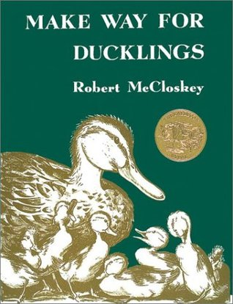
Why you should read this book:
A family of mallard ducks searches for a new home in Boston.
McCloskey, Robert. Make Way For Ducklings. New York: Viking Press 1941.
Title: Owl Moon
Author: Jane Yolen
Call Number: E YOL
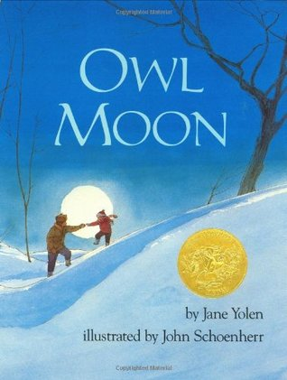
Why you should read this book:
On a winter's night under a full moon, a father and daughter trek into the woods to see the Great Horned Owl.
Yolen, Jane. Owl Moon. New York: Philomel Books, 1987.

